**Guests that have not logged in for the last month (FLOW)**

API Permissions needed: **AuditLog.Read.All and User.Read.All**

# The FLOW:

Import the Flow packed and change the values:

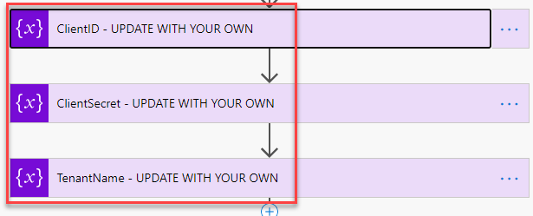

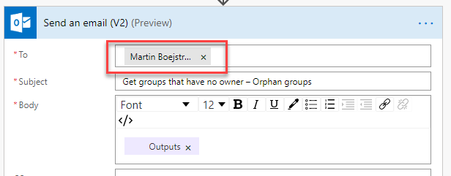

# Sample Result:

